Dr. Jennifer Gargano New Patient Questionnaire

Patient Name:____________________________________Appointment Date:_____________________

Please clearly mark your painful areas. 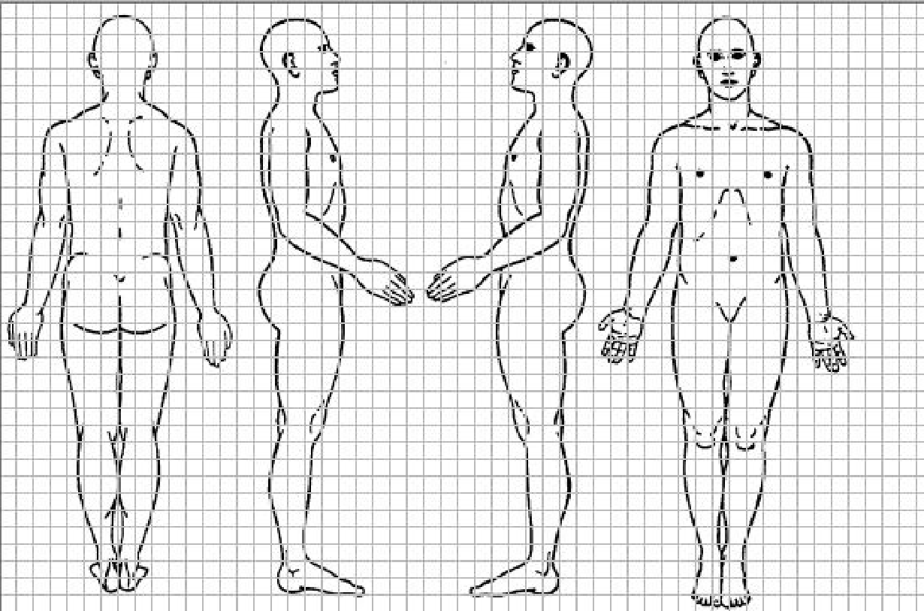

The location of my worst pain is: _________________________________

Circle Current Pain Score: No pain = 0, Worst Pain Imaginable = 10

0 1 2 3 4 5 6 7 8 9 10

Over this past month, Your Best pain score: /10 Worst pain score: /10

When / how did your pain begin? _________________________________________________(month, year)

Was there an injury or accident?_________________________________________

Describe your pain:____________________________ Circle: Sharp, stabbing, aching, burning, lightening shock, electric, dull, sore, sensitive to light touch, tingling, constant, variable, punishing, terrifying

What increases my pain: __________________________________________________________________

What relieves my pain: ____________________________________________________________________

Have you tried: Chiropractor _____Physical therapy _____Injections _______

Current Height: _________ Weight: _________

Current Medications:
Medication | Dosage | # per day | Prescriber

Any pain medications tried?

Medical Problems:

Surgical Procedures and Dates:

Allergies: List Medications and reactions: ________________________________________________________
___________________________________________________________________________________________
Any Allergy to Latex, Contrast, or Shellfish? ______________________________________________________
Is there a family history of any medical problems?___________________________________________
Any family history of drug or alcohol addiction? Yes/No ___________________________________

Social History:
Do you work? Yes/No/Disability ___________________________________________
What is your job?_________________________________________________________
Do you drink Alcohol? Yes/No How often? ____________________
Smoke Tobacco? Yes No How may packs per day? _____ How many years?______
Are you using Recreational or Street Drugs: Yes No
Any history of drug or alcohol addiction or abuse? Yes No
If yes, was this treated and when? _______________________________________________

Have you been having any unusual symptoms? Please circle or check here if none__________
Fatigue, night sweats, weight loss or gain, headache, blurred vision, chest pain, racing heart beat, shortness of breath, heartburn, constipation, difficulty urinating, accidents of urine or stool, low back pain, joint pain, numbness or tingling, anxiety or depression, easy bleeding, rash

Have you been treated for mental health? Yes/No
What kind of treatment:________________________________

Any other concerns today:_____________________________________________________________

Date: ___________ Physician Signature:_______________________________________________

