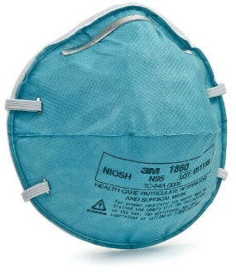
N95 Respirator Training Guide
Covers the OSHA (29 CFR 1910.134) training requirements for disposable N95 filtering face piece respirator users.
What is an N95 Filtering Face Piece Respirator? N95 filtering face piece respirators are air-purifying respirators certified by the National Institute of Occupational Safety and Health (NIOSH) to have a filter efficiency level of 95% or greater against particulate aerosols free of oil and greater than 0.3 microns in size.
Examples of airborne contaminants that N95 respirators filter out include dust, fumes, mists, and microbial agents such as tuberculosis bacteria & flu virus.

When Are N95 Respirators Required? Depending on your job responsibilities, N95 respirators may be required as personal protective equipment. Individuals may be required to wear N95 for tasks such as entering isolation rooms, and other activities involving close contact with potentially infected persons.
Approval for Required N95 Use:
Per OSHA, personnel who are required by their employer to wear respirators, shall be approved after completing the following:
- Medical Evaluation/ Clearance: to determine if users are physically fit to wear a respirator.
- Training: to ensure users are familiar with N95 respirators, their proper use, and protective limitations. Training consists of reviewing this document and taking the training quiz and is required on an annual basis.
- Fit-Testing: to determine which respirator model/size provides the proper fit for the user.
Capabilities and Limitations of N95 Respirators
- N95 respirators ONLY filter out particulate contaminants.
- N95 respirators do not protect you from:
  - Chemical vapors/ gases
  - Oxygen deficient atmosphere
Effective Use of N95 Respirators
The effectiveness of N95 respirators relies on how well the respirator seals to the user’s face. To ensure N95 respirators work effectively:
- ONLY use the respirator model and size for which you have been fit-tested. N95 respirators vary by model and size. Improper fit will likely result in inadequate protection.
- DO NOT use the respirator with beards or other facial hair, which may interfere with the direct contact between your face and the sealing surface of the respirator.
- Conduct a seal-check every time you put the respirator on (before entering the area of concern).
- If the respirator becomes damaged, soiled or you experience problems with using the respirator (breathing becomes difficult, dizziness, irritation, etc.), leave the work area immediately and remove the respirator when you are no longer exposed to the potential airborne hazard. Inform your supervisor about the issue.

Further Medical Evaluation/ Training/ Fit-Testing
- Medical re-evaluation is required if the user reports medical signs/ symptoms that are related to the ability to use a respirator, or if changes in the workplace/ activities may result in a substantial increase in the physiological burden placed on the respirator user.
- Fit-Testing needs to be repeated annually and whenever changes in the workplace/ activities or type of respirator used to affect the respirator fit [i.e. facial/ dental changes and changes in body weight (more than 10- 20 lbs)].
- Training needs to be repeated annually and whenever inadequacies in the user’s knowledge or use of the respirator indicate that the user has not retained the requisite understanding or skill to wear a respirator.
Inspection
Before wearing the N95 respirator, inspect the respirator for damage and contamination. Verify all components of the respirator are in good condition (e.g. straps, nose piece, etc.).
Wearing the Respirator & Seal-Checking Procedures
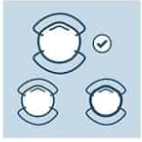
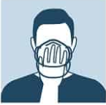
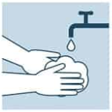

Hold the respirator in your hand and place it on the nose, mouth, and chin
Choose the respirator you have been fitted for.
Wash your hands

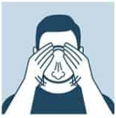
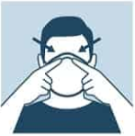
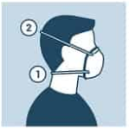

TO REMOVE YOUR RESPIRATOR: With the other hand, pull the bottom strap over your head, and then pull the top strap off. If respirator was used in a medical facility or if there is any evidence that respirator may be contaminated, dispose of it as a bio-hazardous waste.

Perform a fit check: Place hands over the respirator and exhale, adjust if there are leaks
Position the bottom strap under your ears and the top strap at the back of your head
Press the metallic wire to fit the shape of your nose and face

